Apollo PTA 2.6.3  Grant Guidelines 2019-20 | 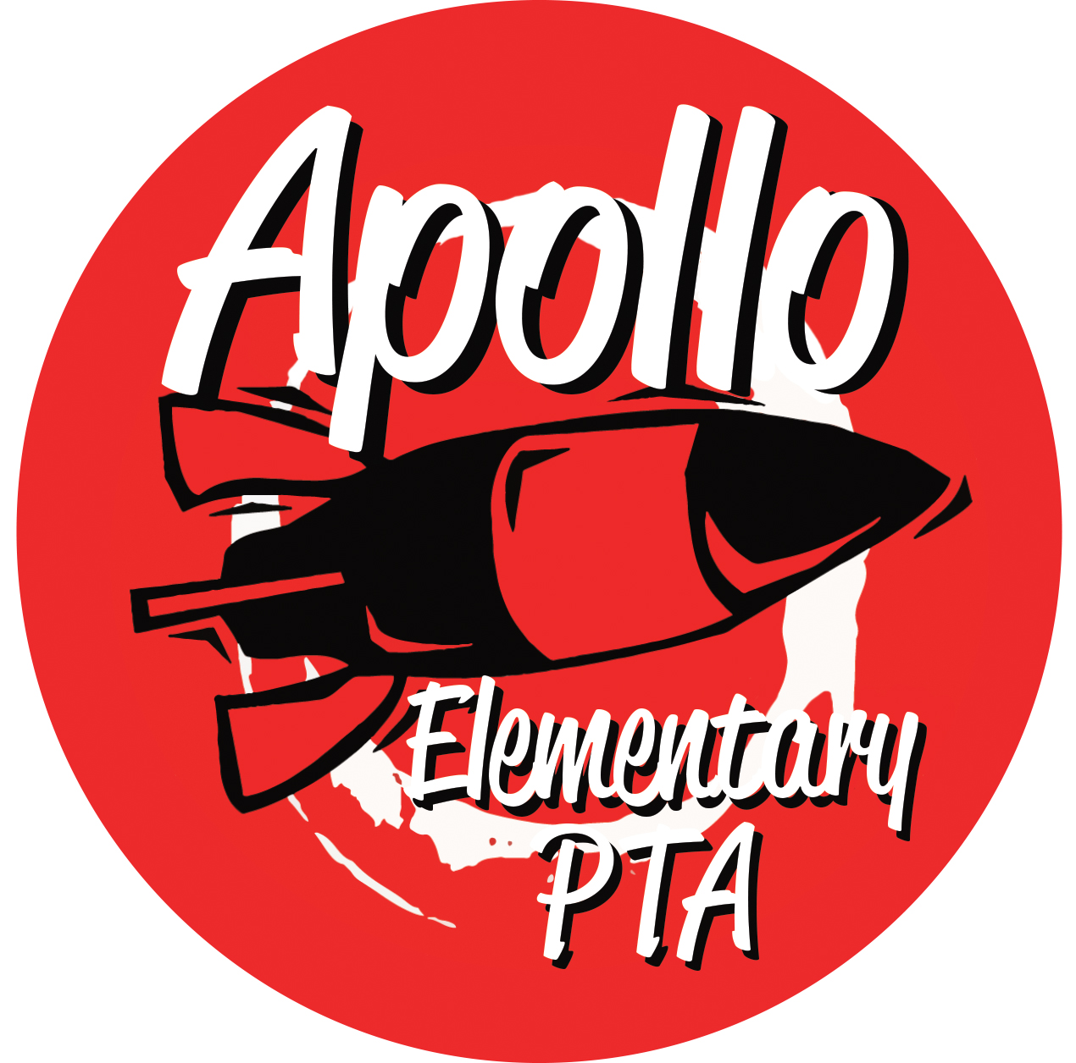

The Apollo Elementary PTA’s mission is to encourage and support a positive school environment with our students, staff, families and community as we strive to be advocates for programs and policies that nurture youth and education. We do this by sponsoring and funding programs, recruiting and mentoring volunteers, and working in collaboration with the Apollo staff.

Goals for 2019-20

- Increase Membership
- Facilitate effective communication with the Apollo community through the use of our new website
- Enhance the education of children through enrichment activities
- Continue to increase parent involvement in the PTA

Deadlines for Applying for Grants:

Grants Due: | Board Meeting Dates: | PTA Meeting Dates:
September 8, 2019 | September 11, 2019 | September 25, 2019
October 6, 2019 | October 9, 2019
November 17, 2019 | November 20, 2019
January 12, 2020 | January 15, 2020 | January 29, 2020
February 9, 2020 | February 12, 2020
March 8, 2020 | March 11, 2020
April 5, 2020 | April 8, 2020 | April 29, 2020
May 10, 2020 | May 13, 2020 | June 10, 2020

Background Information on Apollo PTA Grant Program:

The Apollo PTA welcomes grant requests from the staff and parents of Apollo Elementary. Our purpose is to help fund programs that benefit students through educational and enrichment programs, which ideally will affect a large number of students school- and classroom-wide. Funds should not be used to fund individual students, except in the case of scholarship. Funds are limited and availability may vary from year to year. The Apollo PTA board of directors will review applications and vote on them at board meetings. Grant applicants should be prepared to answer questions during this review process.

Applications may be granted fully, asked to be re-written, be partially funded, put on hold or denied. Incomplete forms or forms without approval signatures will not be accepted. Funds are granted based on a one-year commitment only. Applications must be re-submitted each year and will be subject to funding availability and goals of the current board. Grant applications must address at least one of our PTA’s identified areas of focus as stated in our Mission Statement above (increased communication, student enrichment, increased parent involvement and membership participation). Items purchased by the Apollo PTA must remain on school property should the teacher become employed elsewhere. Grant Applicants should plan on attending the appropriate PTA Board Meeting to present their requests and make arrangements to visit another PTA meeting later in the school year to share success of item/program with the board if grant is approved.

Grants will be evaluated on the following criteria:

- Is it in line with mission statement and goals?
- Is funding available or earmarked for other programs?
- Has a similar program already been funded this year?
- Is it timely to spend funds now – is the need more immediate than others?
- Is there a significant number of students affected?
- Has the applicant considered other sources of support?

How to use this form:

- You can fill out this form by placing your cursor in the gray boxes. The page will expand as necessary.
- After completing the form, please print out, sign, and get Principals’ signature.
- Place completed form (with signatures) in the PTA mailbox by the due date.
- If you have any questions, contact president@apollopta.org

